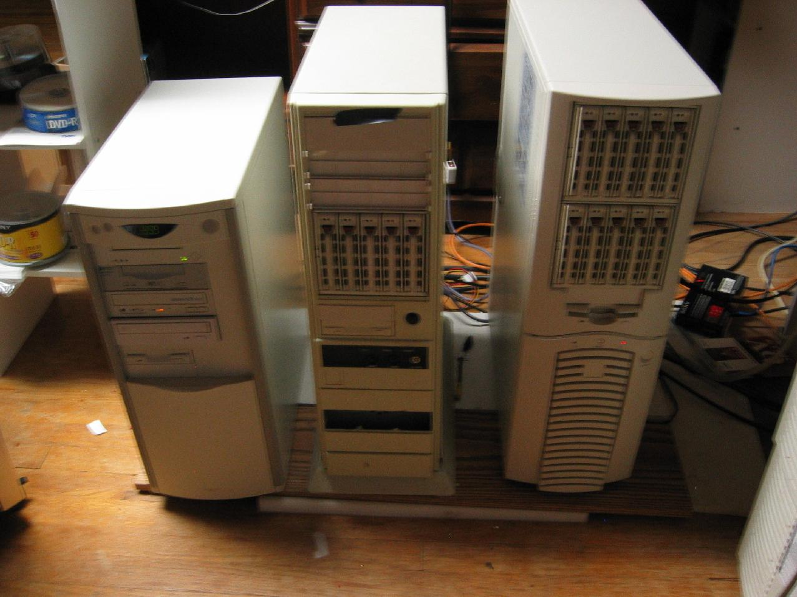

This is my workstation. The three chassis combine for one high end workstation.

My God Box:
Tyan Thunder K8W motherboard
Windows XP x64 AMD64 SP1, Windows XP PRO SP 2 and Win Pro SP4
Dual AMD Opteron 265 processors (dual core 1.8GHz)
3 GB Samsung PC3200 DDR400 Ecc Reg in 128 bit interleaved mode

LSI Logic MegaRAID 320-2X SCSI RAID Controller with 128 MB and battery
2 x Supermicro SCA SCSI U320 enclosures (main chassis)
1 x Supermicro SCA SCSI U320 enclosures (second chassis)

RAID 1: 2 x ST336607LC SCA U320 36GB 10.6K (main chassis)
Common OS boot files in FAT32 partition and XP x64 AMD64 SP1

RAID 1: 2 x ST336607LC SCA U320 36GB 10.6K (main chassis)
OS dual boot: XP Pro SP2 and 2K Pro SP4

RAID 10: 6 x ST336607LC SCA U320 36GB 10.6K (main chassis)
apps and games

Hot Spare: 2 x ST336607LC (main chassis)

RAID 0: 3 x ST336607LC SCA U320 36GB 10.6K (second chassis)
Paging file
temp files
temporary internet files
I386 folders for both OS

Adaptec 39160 U160 SCSI Channel A
HP DAT 40i LVD Tape Backup Unit (third chassis)
Toshiba SCSI-2 DVD-ROM

Adaptec 39160 U160 SCSI Channel B
Exabyte VXA-2 80/160GB LVD Tape Backup Unit (third chassis)
Plextor UltraPlex SCSI-UW CD-ROM (third chassis)

Firewire Direct 64-bit 66 MHz USB2 / Firewire 800 adapter
Plextor PX-708UF USB2 DVD burner
Plextor PX-716UF USB2 DVD burner
ATI AIW X800XT 256MB 8X AGP
Samsung Syncmaster 997MB Monitor
Hercules GTXP 7.1 sound adapter
Harman / Kardon AVR 325 (connected to Audio and Video adapter, TV, Cable Box, VCR/DVD player)

Okidata 10I Laser Printer
Epson Color Stylus 800 Inkjet Printer

Main Chassis
Antec SX-1200 14 device tower case
PC Power and Cooling 510A4 power supply

Second Chassis
AT Tower Case
PC Power and Cooling 400AT power supply

Third Chassis
AT Tower Case
250AT power supply

20A Independent circuit
Tripp Lite 2400W Line Conditioner for computer and monitor
2 xTripp Lite 600W Line Conditioner for printers, AV hardware
Rounded cables on all devices from SideWinderComputers.com

I wanted to reduce the number of chassis from three down to two. It was reduce fan noise from a power supply and extra chassis fans. The Cooler Master Stacker 810 chassis is 11 bay. It will be able to handle the following:

PC Power and Cooling bay-cool fan unit
2 x Supermicro CSE-M35S SCA SCSI U320 enclosures
Up to 10 Seagate 36GB 10K U320 SCSI hard drives (ST336607LC)
Exabyte VXA-320 tape backup
Exabyte VXA-2 tape backup
HP DAT 40i tape backup
Plextor UltraPlex SCSI-UW CD-ROM
Toshiba SCSI-2 DVD-ROM

I needed a power supply capable of handling the spin up load of all these devices. I also wanted a power supply capable of not needing a motherboard to turn on. I spent time looking up each devices spin up load on +5V and +12V. The spin up current on SCSI devices is usually 2x the normal current load. The hard drives load up first on the LSI Logic MegaRAID 320-2X SCSI RAID controller with 512MB Battery Backup Cache. The tape drives, CD-ROM, and DVD-ROM load on the Adaptec 39160 after the 320-2X. The decision was made to have a custom wired power supply with only the leads I needed and have it wired in the on position with only the 0/1 switch on back to disable it. The 20A circuit for the workstation has its own switch to disable power to all plugs. I turn off the workstation and kill power when not in use.

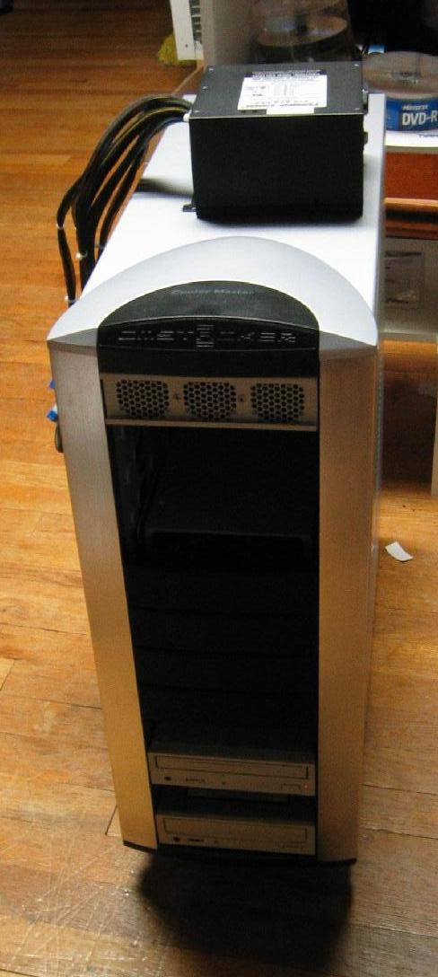

The picture seen here is of the Cooler Master Stacker 810 ($170) and the custom PC Power and Cooling power supply ($240). I have used PC Power and Cooling power supplies for many years. I have one in the main chassis (510AG) for my Tyan Thunder K8W. I use a 600W ATX in my IIS Server on my Tyan Thunder DLUAN-GX server board with dual Intel PIII 550 MHz CPUs, 896MB RAM. It will be soon be upgraded to a Promise Fasttrak 100 TX2 and a pair of Western Digital WD1600SB 24x7 160GB RAID 1 drives.
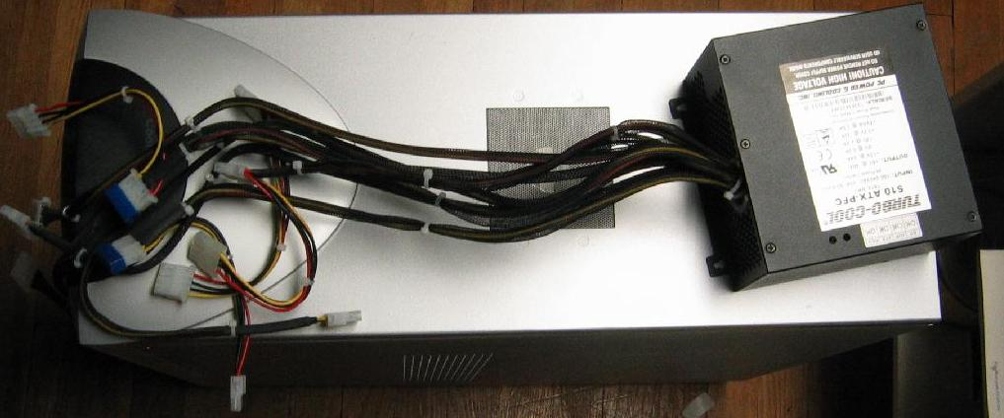

This pictures is a top view of the custom PC Power and Cooling 510W power supply:

I had the following done to it:
- Remove motherboard harnesses
- Remove SATA harness, since all devices are SCSI and use regular molex
- Change all harnesses to custom lengths
- 2 x 25" single molex for upper Supermico CSE-M35S SCA SCSI U320 enclosures, each requires two leads to power 5 hard drives and a 40cfm fan, hot swap
- 2 x 19" single molex for upper Supermico CSE-M35S SCA SCSI U320 enclosures, each requires two leads to power 5 hard drives and a 40cfm fan, hot swap
- 2 x (15" + 6") double molex leads for SCSI devices
- 2 x (12" + 6") double molex leads for SCSI devices and fans
4.) Wired so in always on position. No motherboard or chassis switch required

I wanted to limit the amount of cable clutter in the chassis to improve airflow. I also used rounded cables.

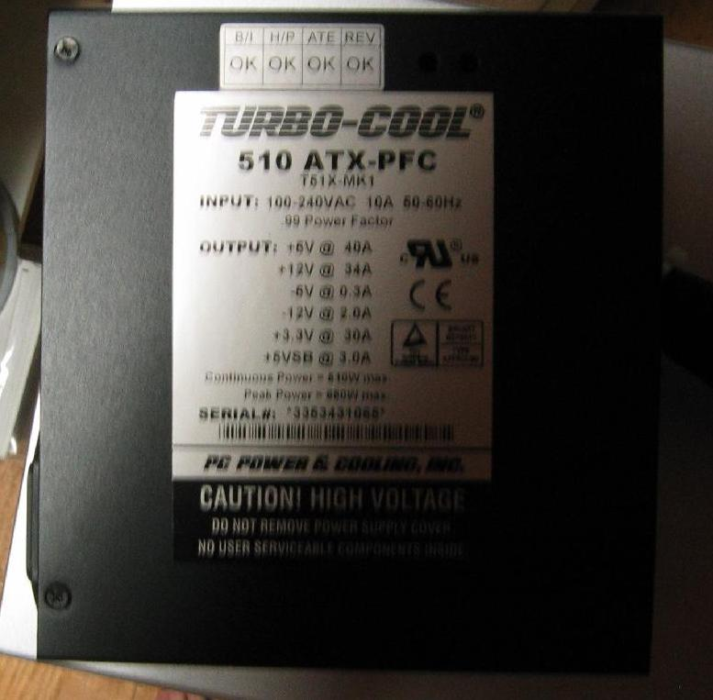

The specs on the power supply are +5V@40A and +12V@34A. My devices will be below 20A on each rail at spin up. The power supply will run cool because it will not get near the limits of the power supply. Both are on a single rail to improve output current. I took the fan wires and use Velcro to attach them to the back wall of the chassis. It came with an upper fan and two rear 120mm fans. I will leave the front 120mm fan in place until I add the fourth SCA enclosure. The SCA enclosure connects to the main chassis 320-2X with two cables.

68-pin internal to 68-pin external
Product Name: ACK-68I-68E-LVD-LP-Round-U320
Product Number: 2029700
Dimension: 18 inches
Suggested Price: $39.00

The cable is 18 inches and allows a single internal to external U320 connection in side a chassis. The SCA enclosures run on a single SCSI U320 cable back to the VHDCI connections on the external of the LSI Logic MegaRAID 320-2X.

68-pin VHDCI/Male to 68-pin HD//Male
Product Name: ACK-68V-68HD-LVD-1M-U320
Product Number: 1986800
Dimension: 1 meters
Suggested Price: $50.00
This is a 1 meter external 68 pin high density from the SCSI enclosure to the VHDCI connection on the 320-2X. The total cable length is just under 1.5 meters. It is the best method of placing SCSI enclosures in a SCSI chassis. You will need one of each cable for each SCA enclosure.

The other SCSI devices use a 68pin slot mounted SCSI-UW 40MHz capable converter from Cyberguys.com

Scsi Internal Adapter Hp68f To Hp68f
Part Number #131 1740
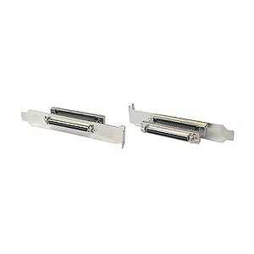
$14.43

You need one for each SCSI channel on your controller.

68-pin VHDCI/Male to 68-pin HD//Male
Product Name: ACK-68V-68HD-LVD-1M-U320
Product Number: 1986800
Dimension: 1 meters
Suggested Price: $50.00

You will also need a 1 meter external cable to connect them to your SCSI controller. The Adaptec 39160 has VHDCI connections externally. Check with your SCSI and SCSI RAID controllers for the correct cable type.

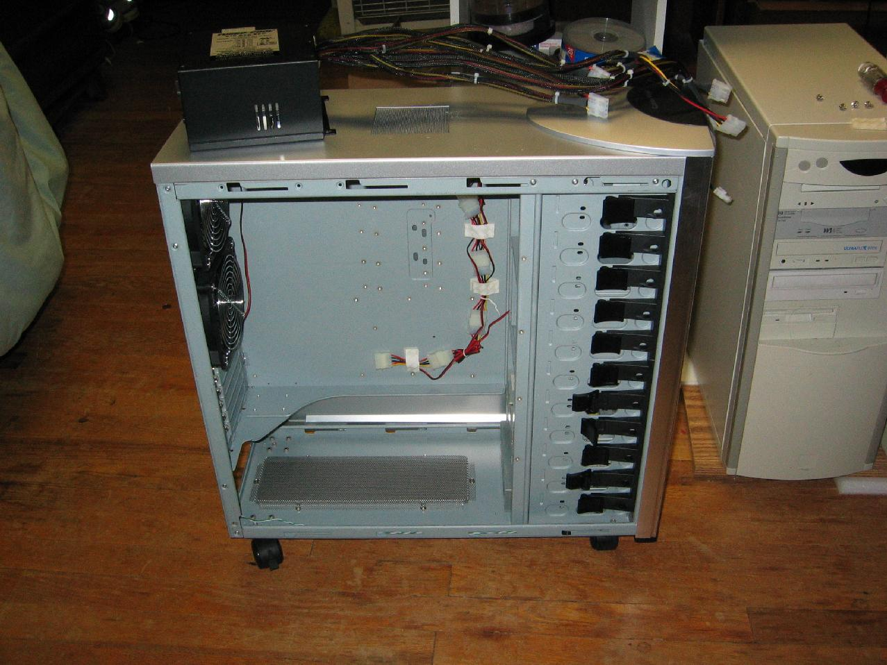

Below is a picture of the custom PC Power and Cooling 510W installed. From left to right

2 x (12" + 6") double molex leads for SCSI devices and fans
2 x (15" + 6") double molex leads for SCSI devices
2 x 19" single molex for upper Supermico CSE-M35S SCA SCSI U320 enclosures, each requires two leads to power 5 hard drives and a 40cfm fan, hot swap
2 x 25" single molex for upper Supermico CSE-M35S SCA SCSI U320 enclosures, each requires two leads to power 5 hard drives and a 40cfm fan, hot swap

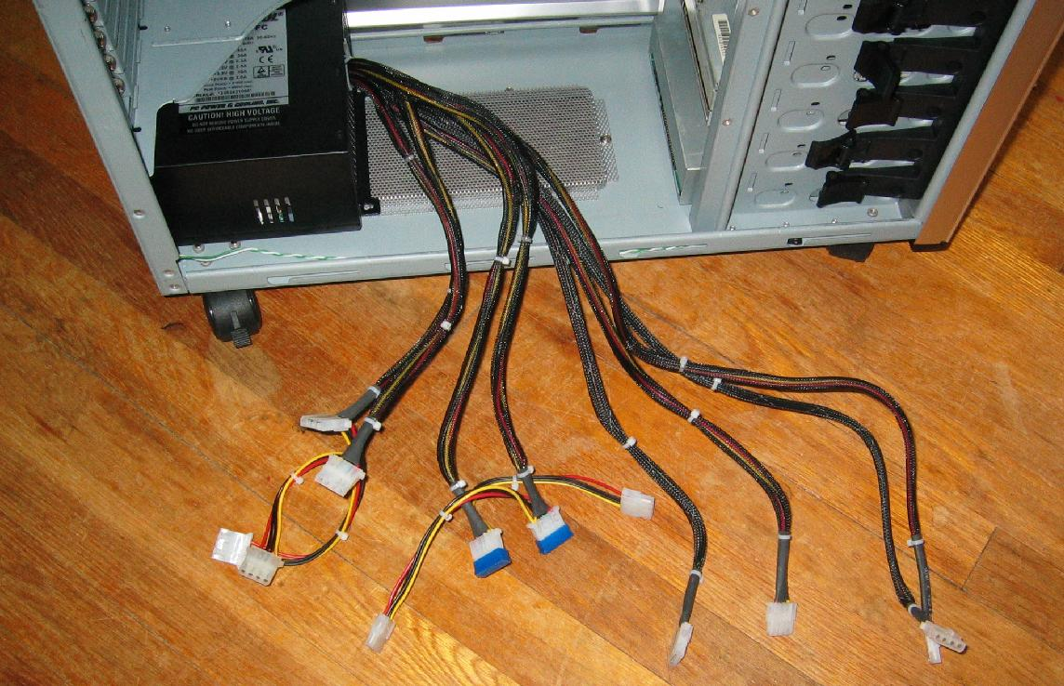
The picture below shows on top of the 810 the CSE-M35S enclosure and its 18" Internal to External U320 SCSI cable and slot connection. Under the fan is the data cable connection and two molex plugs for the power supply

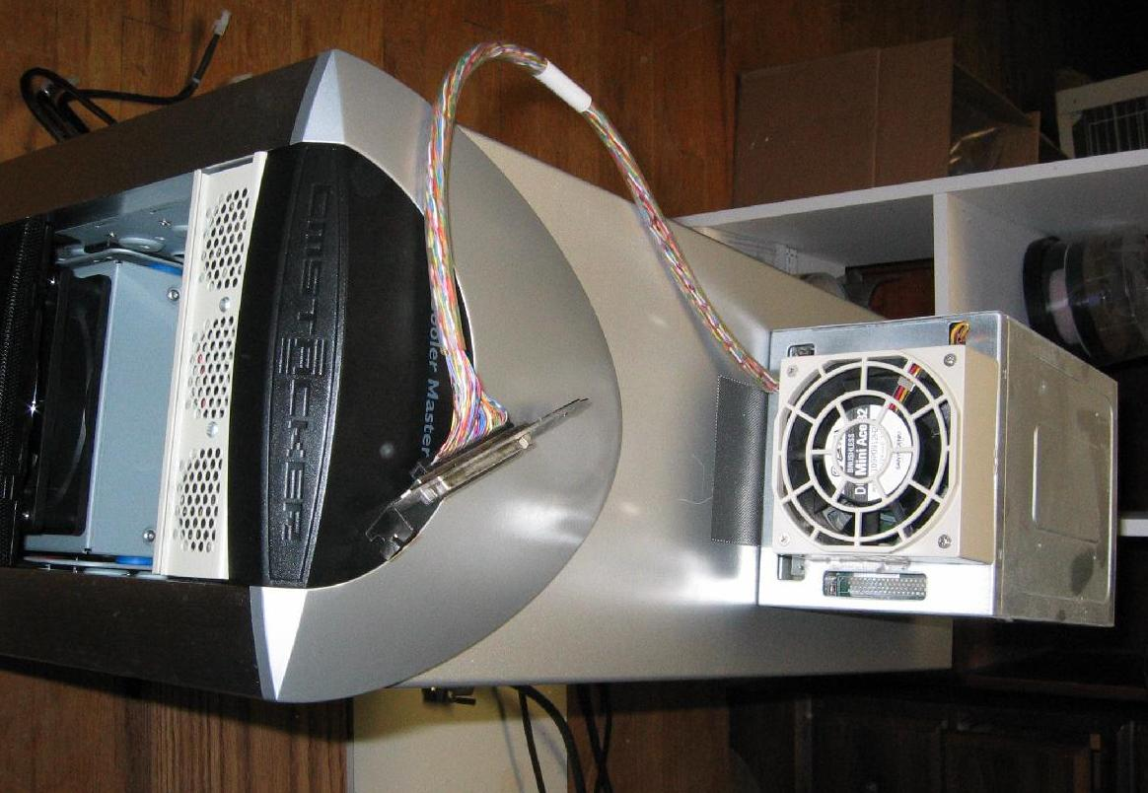

Below is the almost finished project. I ordered the Exabyte VXA-320 and it will be going into the fourth bay from the bottom of the 810.

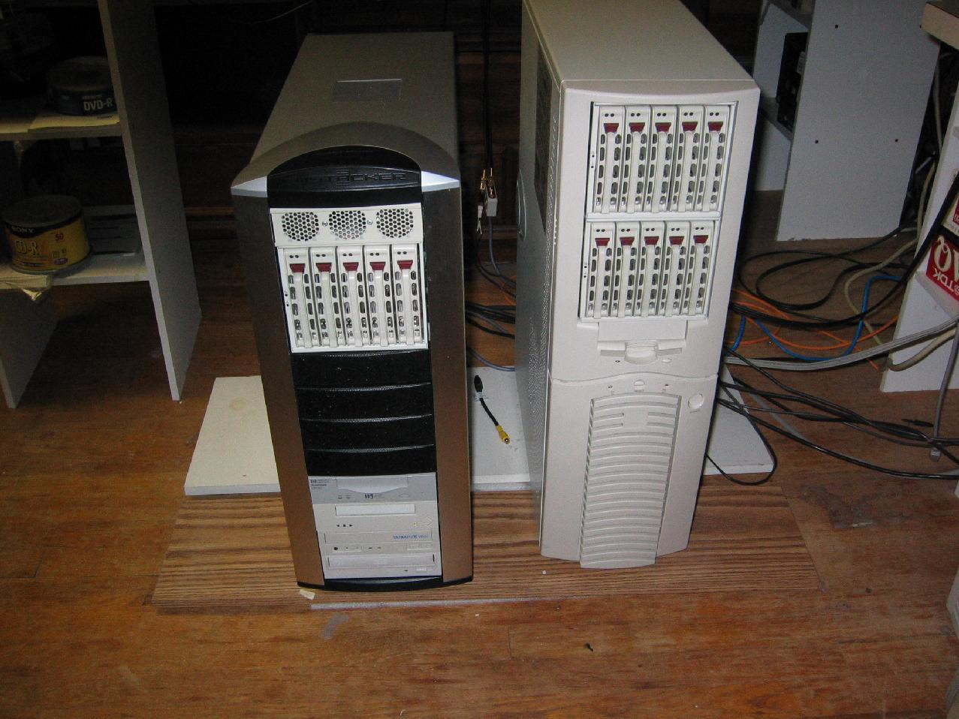

This is how you build your own SCSI enclosure.

Here is the Exabyte VXA-320 Tape Backup. It is 160GB Native / 320GB 2:1 Compression. It will be used to backup my External hard drives.

